Experiment 15:
Aim:
15.Write a Pandas program to keep the rows with at least 2 NaN values in a given DataFrame.
Python code:
import pandas as pd
import numpy as np

# Create DataFrame
data = {
"Name": ["Alice", "Bob", "Charlie", "David", "Eva"],
"Age": [25, np.nan, np.nan, 28, np.nan],
"Marks": [85, np.nan, np.nan, 75, np.nan],
"City": ["Delhi", "Mumbai", np.nan, "Chennai", np.nan]
}
df = pd.DataFrame(data)
print("Original DataFrame:")
print(df)

# Keep rows with at least 2 NaN values
result = df[df.isnull().sum(axis=1) >= 2]
print("\nRows with at least 2 NaN values:")
print(result)
Output:
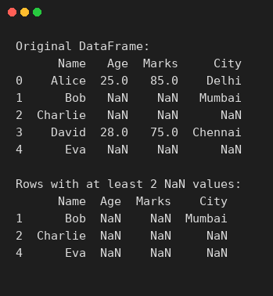

Experiment 16:
Aim:
16.Write a Pandas program to split the following dataframe into groups based on school code. Also check the type of GroupBy object.
Python code:
import pandas as pd

# Create DataFrame
data = {
"school_code": ["s001", "s002", "s003", "s001", "s002", "s004"],
"class": ["V", "V", "VI", "VI", "V", "VI"],
"name": ["Alberto Franco", "Gino Mcneill", "Ryan Parkes", "Eesha Hinton", "Gino Mcneill", "David Parkes"],
"date_Of_Birth": ["15/05/2002", "17/05/2002", "16/02/1999", "25/09/1998", "11/05/2002", "15/09/1997"],
"age": [12, 12, 13, 13, 14, 12]
}
df = pd.DataFrame(data)
print("Original DataFrame:")
print(df)

# Split the DataFrame into groups based on school code
grouped = df.groupby("school_code")
print("\nSplit into groups based on school code:")
for name, group in grouped:
print("\nGroup:", name)
print(group)

# Check the type of GroupBy object
print("\nType of GroupBy object:")
print(type(grouped))
Output:
